**PRODUCT SALES ANALYSIS**

**PHASE-2**

**AIM:**

The of incorporating machine algorithms into product sales analysis to predict future sales trends and customer behaviors can be multifaceted and learning highly beneficial for businesses.

**Incorporating machine learning algorithms for predicting future sales trends and customer behaviours is a valuable approach in product sales analysis. Here are some steps to consider:**

**Data Collection**:

Gather historical sales data, customer information, and any relevant variables that might influence sales, such as marketing spend, seasonality, or economic indicators.

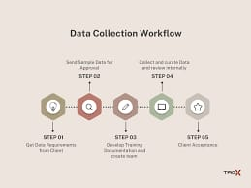

**Data Preprocessing:**

Clean and preprocess the data by handling missing values, outliers, and encoding categorical variables.

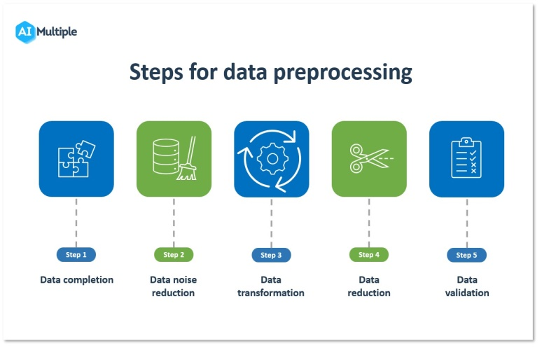

**Feature Engineering**:

Create relevant features that can help the machine learning model better understand the data, such as calculating moving averages, customer segmentation, or time-based features.

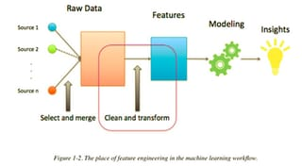

**Model Selection**:

Choose appropriate machine learning algorithms for your task. Common choices include linear regression, decision trees, random forests, gradient boosting, or neural networks.

**Training and Validation**:

Split your data into training and validation sets to train and evaluate the model's performance. Cross-validation can also help ensure model robustness.

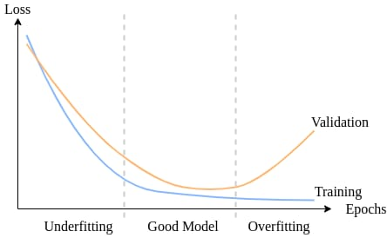

**Hyperparameter Tuning:**

Optimize the model's hyperparameters to improve its predictive accuracy.

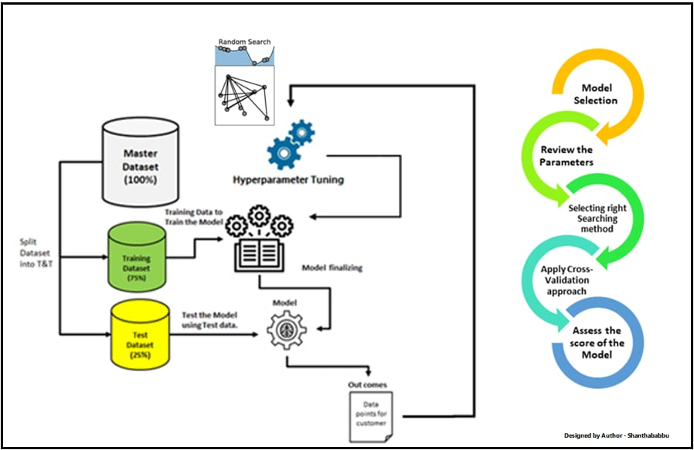

**Interpretability:**

Depending on the algorithm used, ensure that you can interpret and explain the model's predictions, especially for business stakeholders.

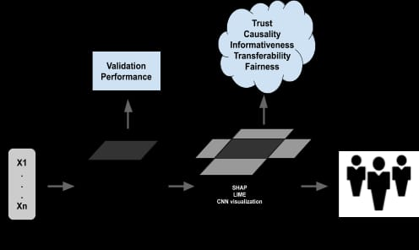

**Deployment:**

Implement the model into your sales analysis pipeline, ensuring it can make real-time or batch predictions.

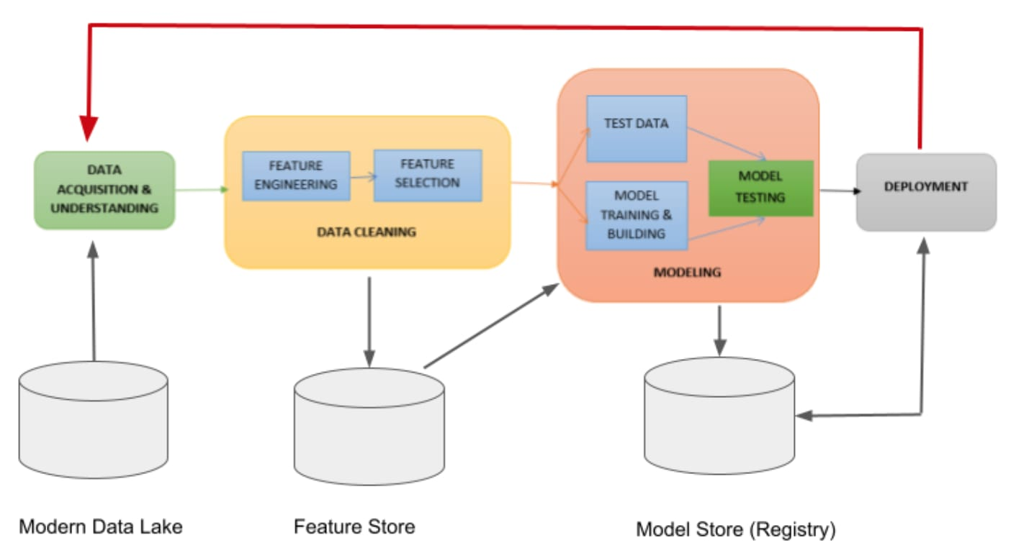

**Monitoring and Maintenance**:

Continuously monitor the model's performance and retrain it periodically to adapt to changing trends and customer behavior.

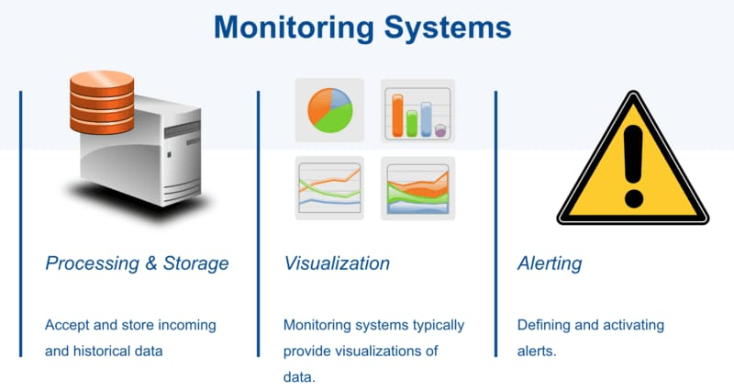

**Feedback Loop:**

Encourage a feedback loop between the model's predictions and decision-makers to refine strategies and improve results.

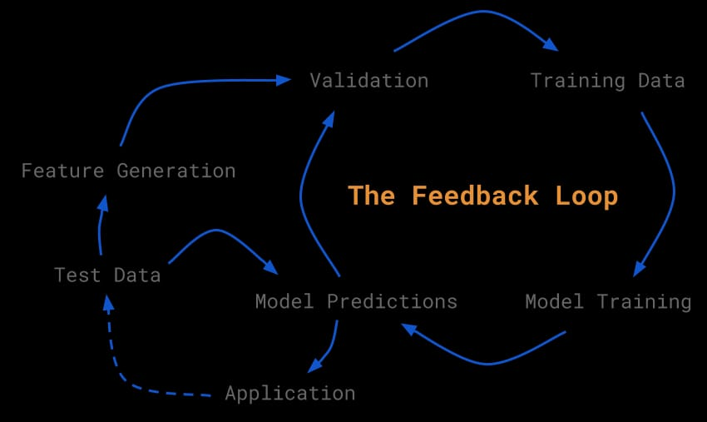

Remember that machine learning is an iterative process, and the choice of algorithms and data preprocessing techniques will depend on your specific business goals and the nature of your data. Additionally, ethical considerations, data privacy, and regulatory compliance are essential when implementing machine learning in sales analysis.

**Decision Tree**:

A decision tree is a supervised machine learning algorithm that can be used for both classification and regression tasks. It creates a tree-like structure where each internal node represents a feature, each branch represents a decision rule, and each leaf node represents an outcome or class.

**Random Forest**:

A random forest is an ensemble learning method that builds multiple decision trees during training and combines their predictions to improve accuracy and reduce overfitting. It operates by creating a forest of decision trees, where each tree is trained on a different subset of the data and uses a random selection of features.

**Algorithm**:

Sure! Decision of trees are a popular algorithm for classification and regression tasks. Random forests are an ensemble method that combines multiple decision trees for better performance. Would you like me to explain how they work in more detail?

**Coding:**

# Import the necessary libraries

From sklearn.tree import

DecisionTreeRegressor

From sklearn.ensemble import

RandomForestRegressor

# Create a decision tree regressor decision_tree = DecisionTreeRegressor()

# Create a random forest regressor random_forest = RandomForestRegressor()

# Train the models with your data

Decision_tree.fit(X_train, y_train)

Random_forest.fit(X_train, y_train)

# Make predictions

Decision_tree_predictions =

Decision_tree.predict(X_test)

Random_forest_predictions =

Random_forest.predict(X_ test)